National Office Use Only
Received
Payment
Approval
USAPL #
1120 Huffman Rd, Ste 24 #223, Anchorage, AK 99515
P: (260) 248-4889 / F: (260) 248-4879
Email: nationaloffice@usapowerlifting.com
Website: www.usapowerlifting.com
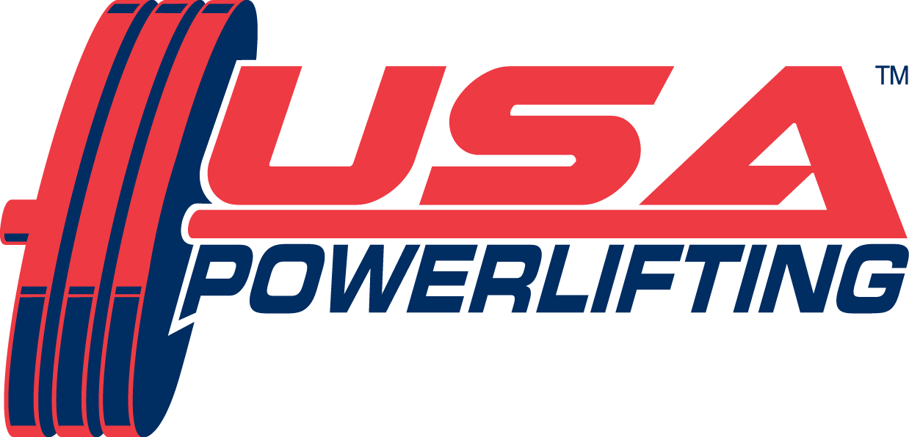

USA POWERLIFTING MEMBERSHIP APPLICATION

PLEASE PRINT CLEARLY

DATE OF APPLICATION: _____/_____/______

First Name: _______________________________________ Middle Initial: ______ Last Name: ________________________________________________

Mailing Address: __________________________________________________ City: _________________________ State: ___ Zip Code: ________

Phone: _____________________________ Email: ____________________________________________________________________________________
XXX-XXX-XXXX you@domain.com

Date of Birth: ___/___/___ Age: ____ Gender: Male Female U.S. Citizen: Yes No

MM/DD/YY
New or Renewal If Renewal, enter USAPL Member number:

Competing Divisions: please check all that apply

 | Open (14+ years) |  | Special Olympian
 | Youth (8-13 years) |  | Non-Compete*
 | Teen (14-19 years)
 | Junior (20-23 years)
 | Master (40+ years)

Membership Type/Prices: please check one
NOTE – Save $10 with Online Membership purchase
√ | Type |  | Price
 | Open, Junior, Master, Non-Compete (14+ years) |  | $65.00
 | Teen (14-19 years) |  | $40.00
 | Youth (8-13 years) |  | $25.00
 | Special Olympian |  | $10.00

USAPL Registered Club Represented (if applicable): __________________________________________________________________________________

DISCLOSURE AND RELEASE
Participating in powerlifting, like most sports, has associated risk of injury. By signing below, should I choose to compete and/or participate in a USAPL competition, I recognize and assume the risk of competing and participating in a USAPL powerlifting meet, and I assume the risk of injury and serious injury. I know that USAPL strongly recommends that I consult my health care provider before competing in the sport of powerlifting to determine whether I am healthy enough to compete. By signing below, I assume the responsibility of choosing to compete whether or not I choose to consult my health care provider. Further, I fully understand that I may injure myself during the competition, including the warming up; however, I hereby release USAPL, its officers, governing board, and employees, the meet directors of any meet that I might compete in, the loaders and spotters who may assist me during the competition, and all referees and officials who conduct the meet for any injury that I may sustain during my warm ups or during the competition, even if I claim or allege that my injury was caused by the fault and negligence of any of the parties that were listed above. Should I compete in a state where I am not able to release a party for fault or for negligence, I intend this release to be applied and interpreted in its fullest capacity and authority according to the applicable law. In consideration of USAPL accepting by membership and permitting me to compete or otherwise participate in a USAPL meet, I, for myself, my personal representatives, administrators, heirs, and assigns, hereby hold harmless USAPL, its officers, governing board, and employees, the meet directors of any meet that I might compete in, the loaders and spotters who may assist me during the competition, and all the referees and officials from any claims, demands, and causes of action, including reasonable legal fees, arising from my participation in USAPL and from my competing in a USAPL sanctioned competition, whether the competition is held in the United States or abroad. I also know that before I sign this Disclosure and Release, I may consult an attorney of my choice to determine whether it is in my best to sign this. By signing below, I affirm that I have read the above, understand it, and agree to it. DISCLOSURE AND RELEASE: I affirm that I have read the above, understand it, and agree to it.

CONDITIONS OF MEMBERSHIP
As a condition of membership to USAPL, I agree to follow and obey all rules, regulations, and drug testing procedures of USAPL. I further agree that the rules, regulations, and drug testing procedures are subject to change at any time and that I agree to obey any new or changed rules, regulations, and drug testing procedures as a condition of continued membership. I agree that my membership may be revoked temporarily or permanently, suspended, and/or denied for my failure to obey USAPL rules, regulations, and drug testing procedures. I will voluntarily submit to any drug testing procedure that USAPL has approved in its rules, regulations, and drug testing procedures. If I do test positive for a banned substance, I agree that the results of the test are conclusive, and I further agree to accept the consequences of that positive test regarding my membership. As a condition of membership to USAPL, I understand and accept that I am prohibited from using any substance or doping method that is banned by the World Anti-Doping Agency (WADA) / United States Olympic Committee. It is my sole responsibility to stay current with any WADA banned substance or doping method, including those most recently banned. I further accept sole responsibility for what I take into my body and that should I consume a banned substance unknowingly, and test positive for that banned substance, I shall be solely responsible for the consumption of that banned substance and shall accept the results and consequences of that test. If I am suspended from membership for any reason, including testing positive for a banned substance or doping method, I permit USAPL to publish my name as a suspended member and/or a member who is suspended for testing positive for a banned substance or doping method on the Internet, or any other publication that USAPL so chooses. *Non-Compete Membership is not subject to drug testing. CONDITIONS OF MEMBERSHIP: I affirm that I have read the above, understand it, and agree to it.

PAYMENT FOR MEMBERSHIP

All memberships expire December 31 of the year purchased, except purchases November and December which expire the following year end. Allow 4-6 weeks process time.

Select one payment method: (Credit cards are no longer accepted at meets unless the meet director is using Square)
___ Cash  ___ Check/Money Order: number_______ | ___ Credit Card:  ONLY ACCEPTED at Meets with Square reader or CALL National Office with Credit Card # | Card # Last 4 digits -___________  Card Type (Visa/MC/Discover/AMEX):____________ | Staff Accepting: ________________  National Office Verification _______

SIGNATURE: Signatures are required for membership. Your signature affirms that you have read all the above, understand it, and agree to it.

Applications Signature: _________________________________________ Applicants less than 18 years must have parent or guardian initial: ______

White Copy – National Office Yellow Copy – Member
Application Form – Membership, updated 10.06.17 pr

