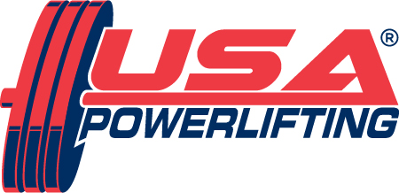

DESIGNATED BENEFICIARY PROGRAM

Tax deduction 501 (C) (3) TIN: 64-0667928

Please check which category donation applies to:

- INDIVIDUAL ATHLETE’S DONATION

Athlete’s Name:________________________________________________________

Athlete’s Address:______________________________________________________

City:_______________________________State:___________Zip:_______________

Phone:_____________________Email:_____________________________________

- TEAM DONATION
Team Name:___________________________________________________________

- USA POWERLIFTING ASSOCIATION DONATION

AMOUNT OF DONATION: $______________________

Donor’s Name:___________________________________________________________

Donor’s Address:_________________________________________________________

City:__________________________________State:___________Zip:_______________

MAKE CHECKS PAYABLE TO: USA POWERLIFTING

MAIL TO: USA Powerlifting National Office
1120 Huffman Rd, Ste 24 #223
Anchorage, AK 99515

